This feature allows transfer data recorded in the NEMRC Land Records program to be transferred to the Listers working grand list program. This process reduces duplication of data entry of property transfer information. Here are a couple of things to keep in mind about this routine.
- This is an optional tool and can be used by any town that the Land Record and Grand List programs. However the Listers Working Grand List and Land Records must be on the same workstation or shared via a Network.
- You select which land record instruments should be transferred into the grand list.
- Any Land record to be transferred must have a valid parcel id. That parcel id must exist in the Grand list before that information will be transferred.
- On the Grand List side - The Listers must review the list of records you have sent from the Land Record program. They have the ability to remove any record that you send over, they can edit the information if needed. (this does not affect what you have entered in your Land Record program.

Here is how to use this tool. You will need to know some basic Grand List information. As in Parcel Id Length and which grand list entity is the working grand list. (Usually entity # 1 Townname) IE: #1 Town of Sutton. Please call support for assistance with this step. (800 387 1110)
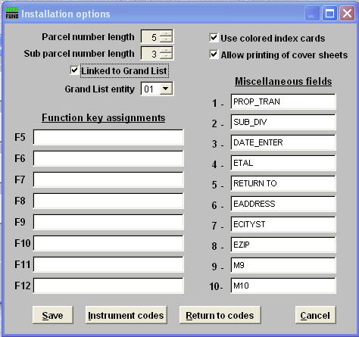
- From the Land Record Main Menu select ‘I Installation’
  - You need to fill in the Parcel # Length, Sub # length,
Check the box ‘Linked to Grand List’
and identify the Grand List entity # as seen here.

b. Press the ‘Save’ button when finished.

- You will notice option
‘4 Transfer to the Grand List’
is now available on the Main Menu.
The program will display the number
of records waiting to be transferred.

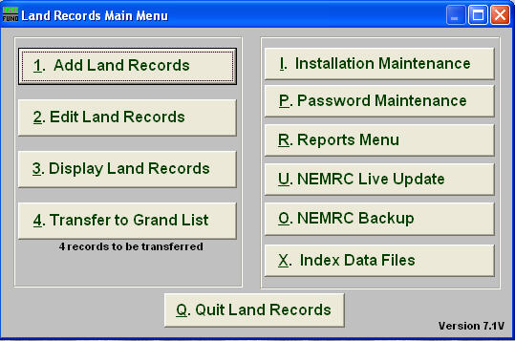

- Adding records to be transferred.
  - Select ‘1 Add Land Records’ and enter the data appropriately – You must enter a valid ‘Parcel ID’ You can add the parcel id at a future time and select it to be transferred at a later date. BE CONSISTENT WITH THE WAY YOU ENTER INFORMATION. GRAND LIST DATA IS ENTERED IN ALL UPPER CASE. Be aware of punctuation as well the Listers may not use commas between last and first names.
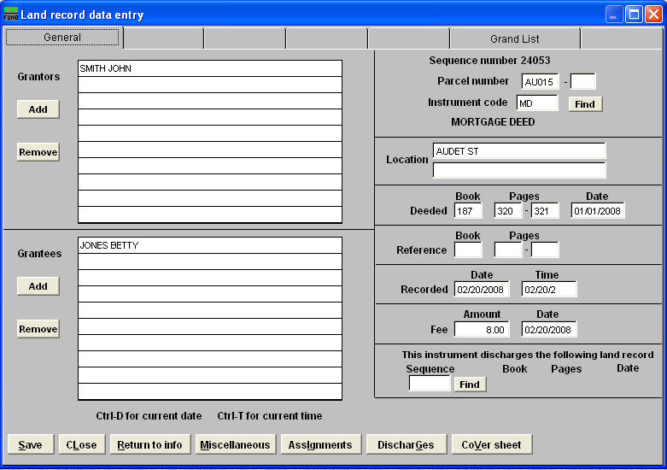

b. Click on the Grand List tab
Check the button to transfer to the grand list
Then fill in the information below. If there is a piece of information you do not know you may leave it blank and the Listers may fill it in when they review the data upon the import process.
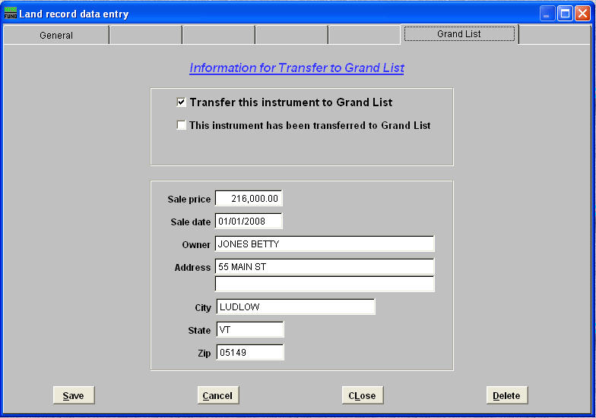

c. Press the Save button when finished.

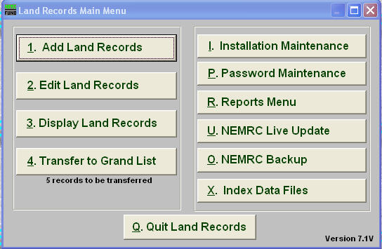
- Now on the Main menu use there is
one more recorded added to the transfer
number.

- Transferring the data to the Grand List program. Select ‘4 Transfer to Grand List’ on the Main Menu. It will list all parcels you flagged to be transferred to the grand list. Once a record is transferred to the grand list then it will be removed from this list. Definition of columns:
  - Transfer – A check mark means this record will be included in the transfer to the grand list. If you can not place or there is no check mark next to a record then that parcel id does not exist in the Grand List program The listers either have to add that parcel or the parcel id has been entered incorrectly and you will need to correct it before you can proceed transferring that record. Use the ‘Mismatched parcel Report’ on this screen to identify those records and review them with the Listers.
  - Valid Sale Price - You may not know if the sale of a property was valid or invalid so you might have to leave this box empty and let the Listers enter that information.
  - Reason for valid or invalid sale price – Again you may have to leave this for the Listers to enter.
4. Press the Transfer button to transfer this information to the Grand List.
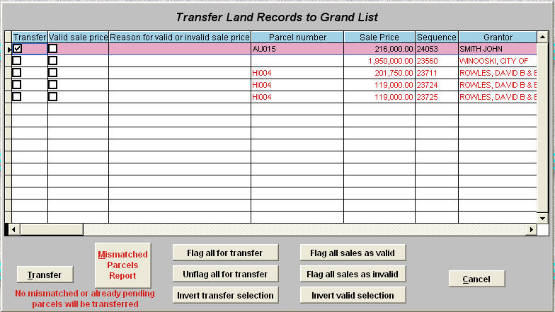

5. Next a transfer report will appear to show you a list of parcels that you have sent to the grand list. Below is an example of this report.

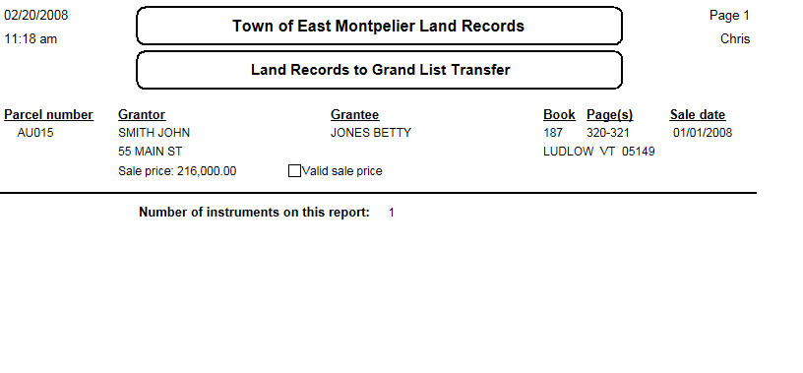

- Now Listers take control of the import into the Grand List.
They will open the Grand List program and click on the button ‘Receive from Land Records’
This option will not show unless the Grand List and Land Records have been linked. The option will not show on any other grand list entity such as an ‘As billed entity’
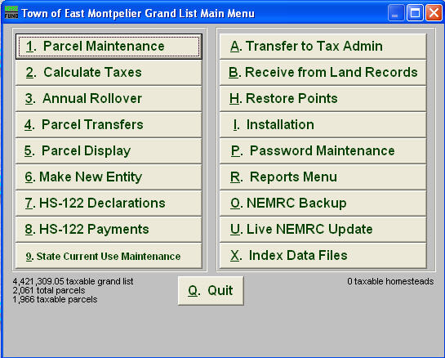

- Next the Listers can review the records transferred from the Land Record Program and edit whether a transfer is valid, provide a reason, and change the sale price if needed. They have the ability to remove a record from the transfer file by pressing the ‘Remove from Pending’ button seen in the second column now. By pressing the ‘Transfer now’ button they can review more of the parcel detail you provided in the Land records. Once they are finished editing the information they can press the ‘Save’ button.

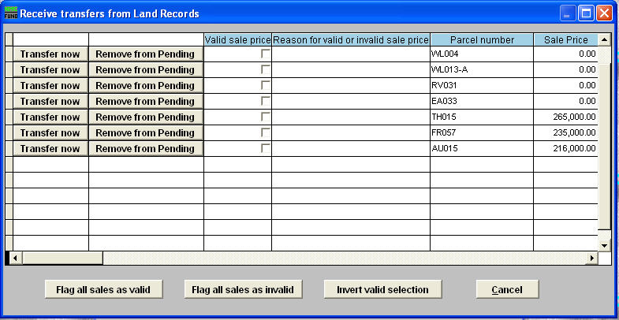

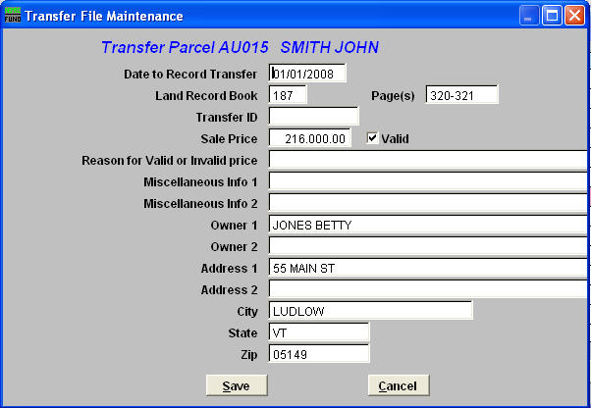

8. Now the Listers can bring up the record in ‘Parcel Maintenance’ and the new owner information will appear along with the Transfer information about this record.

